**Are We Too Dependent on Technology?**

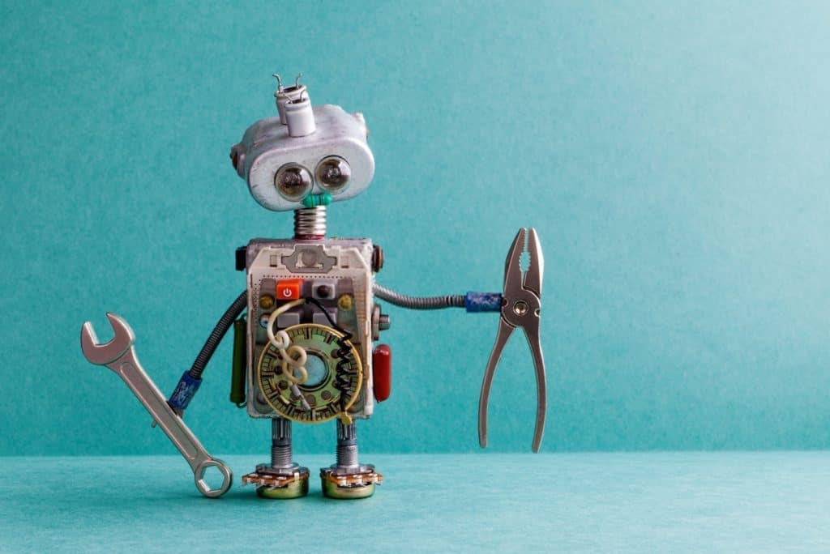

* [Terry Brown](https://itchronicles.com/author/terrybrown/)
* [March 31, 2020](https://itchronicles.com/2020/03/31/)
* Reading Time: 10 minutes

When I was but a young, fresh-faced whipper-snapper at school, I learned to do math in my head. I had my times tables up to 20 memorized and knew a slew of mental math tricks I could call upon to add, subtract, divide, or multiply any two numbers you threw at me. Over the years, however, no doubt, as I became lazy and complacent during my teens, I learned another trick – reach for my calculator. Today, if you were to give me a relatively simple sum like 74 + 113 – my hand would instinctively delve straight into my pocket for my smartphone. Why? Because, in all truth, it would probably be quicker – I’ve become so dependent on technology to perform calculations (calculators, smartphones, spreadsheet software) that I’ve lost all confidence in my ability to perform even simple sums in my head. In fact, sadly, now that I think about it, I’ve forgotten most of my multiplication tables, and those mental math tricks have all but vanished.

Table of Contents

* [Are We Too Dependent on Technology?](https://itchronicles.com/technology/are-we-too-dependent-on-technology/#Are_We_Too_Dependent_on_Technology)

I can take some dubious solace in the fact that I know I’m probably not alone here. As a society, we have become dependent on technology to perform everything from mathematical calculations to communicating with friends, paying our bills and ordering a pizza. Hell, my cell even reminds me to go to sleep at night – and my smartwatch commands me to “Move!” when I’ve been sat on my butt too long.

But technology is, of course, the great enabler of the modern age. Cars, planes, Google, smartphones, computers, business software – it all makes us more efficient and less prone to errors. But it begs the question – what would happen if we had to go without our contraptions and gadgets? If computers and applications are our minds and our memories and machines, our hands and legs, could we cope without them? Could it be that we’ve become too dependent on technology? For all its power to increase our capabilities in both our private and professional lives, is our reliance on technology changing – even damaging – our brains?

**Who Needs Knowledge?**

London taxi drivers are excellent navigators. To become licensed, they must pass the world-famous “[Knowledge of London](https://www.whatdotheyknow.com/request/89944/response/219108/attach/3/Blue%20Book%20All%20London%20no%20cover.pdf)” test – usually abbreviated to “The Knowledge.” To do so, they’re required to memorize hundreds of routes and landmarks and demonstrate their knowledge of them in test situations. They commit to memory thousands of street names and can mentally visualize hundreds of journeys across the UK’s biggest city. This impressive cognitive map is evident on an MRI scan – in an enlarged part of the brain called the hippocampus.

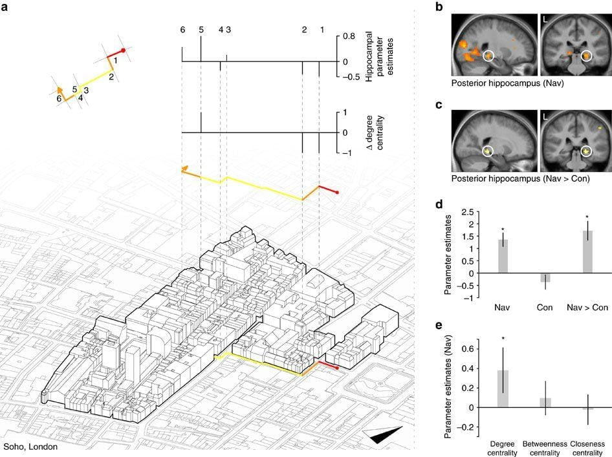

(Image source: [nature.com](https://www.nature.com/articles/ncomms14652/figures/3))

However, as sat-navs and [GPS technology](https://itchronicles.com/artificial-intelligence/the-impact-of-driverless-technology-on-independent-driving-jobs/) have become commercially available and widespread, there have been calls in recent years for The Knowledge to be scrapped. Who needs to rely on their own memories in the digital age, right?

ThiWell, a 2017 study by researchers at University College London (UCL) – published in [Nature Communications](https://www.nature.com/articles/ncomms14652) – claims that when using automated systems to memorize directions and guide us where we need to go, the hippocampus and other areas of the brain used to think of different routes are “switched off.” In other words, when we are dependent on technology for navigation, parts of our brain cease to be used – and when that happens, they stop growing.

“Entering a junction such as Seven Dials in London, where seven streets meet, would enhance activity in the hippocampus,” said the researchers. “When we have technology telling us which way to go; these parts of the brain simply don’t respond to the street network. In that sense, our brain has switched off its interest in the streets around us.”

While we’re not all London cabbies, most of us these days now take turn-by-turn instructions from a GPS device to take the stress out of navigation. But scientists are finding that an underactive hippocampus could have broader implications for our health and well-being, particularly in terms of [child development](https://itchronicles.com/education/the-lack-of-tech-in-education-is-not-preparing-our-kids-for-the-future/), mental health, and [dementia](https://www.helpguide.org/harvard/whats-causing-your-memory-loss.htm). By not regularly exercising the brain, just like a muscle, it becomes weak and unhealthy. As a result, we suffer declines in cognitive ability and memory power – and that has consequences.

**Are There Business Costs of Being Too Dependent on Technology?**

The two most costly words in business are “I forgot.” That’s according to memory optimization expert and CEO of Kwik Learning, [Jim Kwik](https://www.linkedin.com/in/jimkwik/), whose upcoming book, [*Limitless*](https://www.amazon.co.uk/dp/1401958230?tag=skim1x189132-21), explores the concept that the human mind’s potential is virtually unlimited – and the key to unlocking that potential lies in memory training.

I forgot your name. I forgot about this meeting. I forgot the figures. I forgot about that assignment. None of this is good for business. As we become so dependent on technology to remember things for us, our actual memories suffer. Kwik calls this the “digital deluge,” where “our 200,000-year-old brains are overwhelmed by and outsourced to exponentially improving technologies.”

In today’s fast-paced knowledge economy, an organization’s success depends on information and the ability of both leaders and employees alike to master countless volumes of it. With the sheer [mountains of information](https://itchronicles.com/big-data/what-are-the-core-characteristics-of-big-data/), we all face daily, the ability to quickly recall what we need to remember is a vital business skill. Memory lapses at the wrong time can hurt a business relationship or kill a sale. Allowing our brains to “switch off” lose focus, and stop growing as we become increasingly dependent on technology, therefore, could be detrimental to our businesses in all sorts of ways.

For example, in 2019, [$83 billion](https://trainingmag.com/trgmag-article/2019-training-industry-report/) was spent on corporate training and development across the US. But the average person forgets about 70% of new information within 24 hours, and 80% within a week. Like my long-unused multiplication tables and mental math tricks I learned at school, the rest of it – along with billions of corporate dollars – vanishes into thin air. And it’s not just training materials, of course. Names, numbers, client information, product information, sales scripts – is this crucial information in your head, ready to utilize to give your organization a competitive edge? It could be, according to Kwik. There is no such thing as a bad memory, he says – just an untrained memory that is too dependent on technology ever to be put to use.

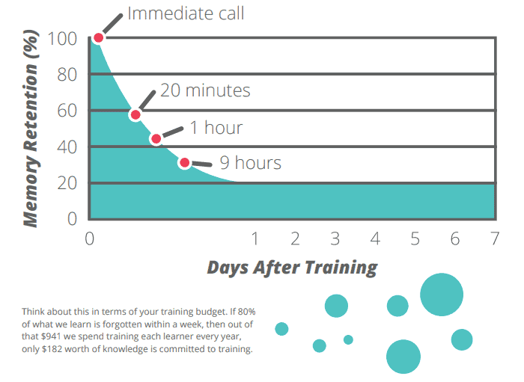

(Image source: [bizlibrary.com](https://pages.bizlibrary.com/rs/230-MIF-751/images/the-science-of-employee-training.pdf?_ga=2.235912322.2074189524.1585309704-1091454570.1585309704))

**Digital Amnesia**

Kwik’s overall message is that the brain needs to be constantly challenged to save it from slipping into “digital amnesia” – a phrase first coined by Kaspersky in a [study](https://media.kaspersky.com/pdf/Kaspersky-Digital-Amnesia-Evolution-report-17-08-16.pdf) of the phenomenon in 2015.

Among other things, the research discovered a direct link between the availability of data at the click of a button and a failure to commit that data to memory. Since its publication, which sought to find out how the use of the internet and [internet-enabled devices](https://itchronicles.com/iot/history-of-iot-what-it-is-how-it-works-where-its-come-from-and-where-its-going/) were transforming people’s lives and relationships, we have become even more dependent on technology as an extension of our brains – and the technological devices themselves have gotten smarter and smarter. Phones now have [biometrics](https://itchronicles.com/cloud/biometrics-cloud-area-rapid-growth/) instead of passwords; they serve as wallets and have voice-activated [virtual assistants](https://itchronicles.com/technology/the-pros-and-cons-of-speech-recognition-and-virtual-assistants/) and apps for almost every task imaginable.

In 2019, Kapersky [revisited](https://media.kasperskydaily.com/wp-content/uploads/sites/85/2019/11/18092002/Digital-Amnesia-Report.pdf) some of the main questions from its initial research to find out if people still suffer from digital amnesia – and if its effects are becoming more common.

The long and the short of it is that they are, according to the study. Take phone numbers, for example. “In the original report, there were personal phone numbers that a majority of participants were able to recall without first looking them up. When revisiting the survey, the findings showed that these numbers were still remembered, but with a lower percentage of people who could actually do so.”

In 2015, 70% of people were able to recall their partner’s phone number. Four years later, that number decreased to 60%. Similarly, 68% of people could call their parents without first looking up the number to dial – but by 2019, only 64% could.

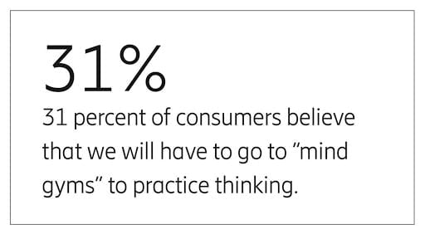

(Image source: [~~ericsson.com~~](https://www.ericsson.com/en/reports-and-papers/consumerlab/reports/10-hot-consumer-trends-2019#trend7mentalobesity))

Forgetting phone numbers may seem trivial on the surface. But the concern is that as we become more and more dependent on technology to remember things like phone numbers, we are decreasing our very ability to learn and retain information *of any kind*. Every time we reach for our smartphone to look up information we could have easily remembered, it seems that we are weakening our memories and eroding our cognitive capabilities.

**Getting Real About Technology**

And what about in the physical world – are we too dependent on technology here, too? Robots are now routinely used to perform surgery in hospitals, and there are, indeed, a number of benefits to this approach. Instead of operating on patients through large incisions, [robotic surgery](https://www.nature.com/articles/d41586-019-02874-0) is minimally invasive, which means it relies on miniaturized surgical instruments that fit through a series of roughly quarter-inch incisions, reducing the risks of scarring and infection, and ensuring a shorter recovery period.

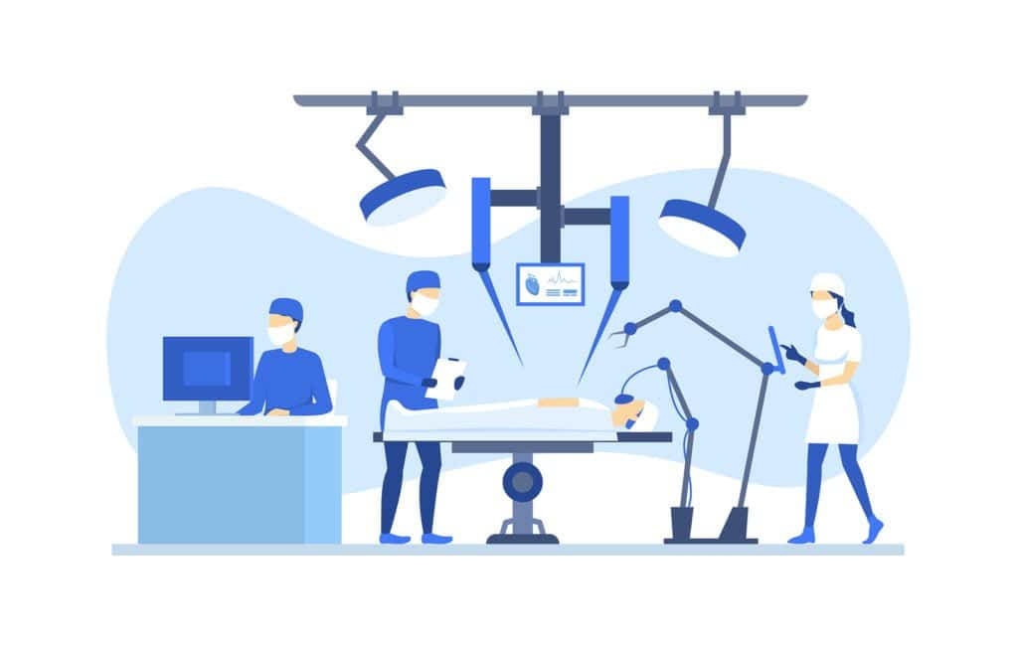

However, an inevitable side-effect of using robotics to perform surgery is that existing surgeons may start to “lose their touch” when it comes to operating on patients directly – and, as the technology progresses, trainee surgeons may never learn to perform manual surgery at all. Tomorrow’s surgeon could be an engineer with very little actual medical knowledge whatsoever. This is fine so long as the machines are working – but do we really want to become so dependent on technology that we can no longer perform life-saving medical operations without it?

Something similar is happening in the world of diagnostics, where AI is increasingly being used to perform diagnoses and, in some cases, can [outperform doctors](https://www.medicaldevice-network.com/features/ai-diagnosis/) in detecting conditions like diabetes, skin cancer, and dementia. As IDx Technologies – a leading AI diagnostics company – Founder and President, [Dr. Michael Abramoff](https://www.linkedin.com/in/michael-d-abramoff-036b61a/) put it: “Autonomous AI systems have a massive potential to improve healthcare productivity, lower healthcare costs, and improve accessibility and quality.” But, once again, is there a danger that at some point in the future – when we’ve become so dependent on technology that we can neither diagnose nor operate on patients by hand – that we would be left without the ability to treat the sick and wounded if that dependence were to be suddenly cut off?

And what about the life-and-death of businesses? How many factory workers today can build and assemble their products without automated machines? Can business and financial professionals collect, collate, and [analyze data](https://itchronicles.com/big-data/data-analytics-vs-data-analysis-whats-the-difference/) to make crucial decisions without the aid of software? Does anybody have any practical, transferrable skills any longer, or have we already become button-pushing zombies, our whole lives, and economies – both micro and macro – at the mercy of machines? If we are dependent on technology to think, live, communicate, travel, and work – who’s really the slave, and who’s the master?

**Final Thoughts**

So long as it works – which it does – some might argue that debating whether or not we are too dependent on technology is moot. I, for instance, don’t need my times tables for my line of work, and if a situation should ever arise when I do need to know the answer to 74 + 113, the calculator on my smartphone (or even Siri) will tell me that it’s 187 (it is – I’ve just checked). And the same, of course, holds true for manufacturers, financial professionals, doctors, surgeons, London cabbies, and all other modern professionals who are dependent on technology every single day to do their jobs with greater efficiency, reliability, and accuracy.

The truth is that the world would have to be facing a truly apocalyptic scenario for our perhaps over-dependence on technology to be exposed – at which point we wouldn’t have a lot of use for our remaining manual and cognitive skills in any case.

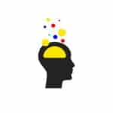

Even so, there’s still the underactive hippocampus to consider. We, of course, want to have healthy, well-functioning minds – if not necessarily to remember phone numbers or the square root of 81, then to be sharp, focused and productive in our daily and professional lives, and stave off depression and dementia.

Are we too dependent on technology? One thing’s for sure – the less we use our brains, the weaker they become, and that can have all sorts of implications from career prospects to mental health. But here’s another certainty – we cannot remove technology from the equation. It’s simply too ingrained into our lives, our businesses, our infrastructure, and our society. We are indeed dependent on technology – whether or not that dependence is too great for our own good will likely come down to the individual who uses it.

If you’re addicted to your mobile phone, feel anxious when you can’t get online, spend more time on [social media](https://itchronicles.com/opinion/social-media-mental-health/) than meeting real people face-to-face (and [feel uneasy when you do](https://itchronicles.com/technology/does-technology-make-us-more-alone/)), or can’t perform simple math in your head – then it may be that you’re too dependent on technology and need to make time to unplug from it every once in a while. Your brain is a precious thing – it’s who you are. Look after it, and you look after yourself. I certainly need to. When it comes to the workplace, if your office can’t function when the internet goes down, and you send your employees home for the rest of the day, then your business may be too dependent on technology. And if your employees are suffering memory lapses at key times (meetings, presentations, sales calls), they might be too.

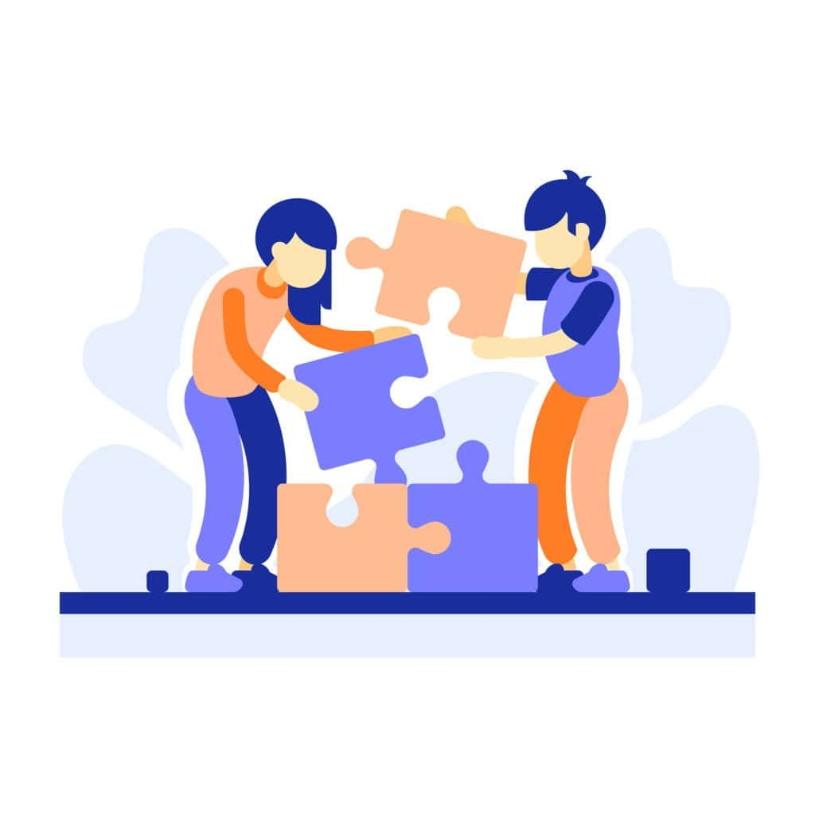

In the end, it’s all about balance. Of course, continuing technological advancements will mean that [more and more tasks get assigned to machines](https://itchronicles.com/automation/rpa/robotic-process-automation-everything-you-need-to-know-part-1/). The important thing is that we recognize the potential impacts – and take action to combat them by using our own cognitive abilities as much as possible. In this way, we can keep our creativity, productivity, focus, and mental health in good working order as we use technology – because, at the end of the day, whether we are too dependent on technology or not, it isn’t going anywhere any time soon.

**Summary:**

Are We Too Dependent on Technology?

But technology is, of course, the great enabler of the modern age. Cars, planes, Google, smartphones, computers, business software – it all makes us more efficient and less prone to errors. But it begs the question – what would happen if we had to go without our contraptions and gadgets? For all its power to increase our capabilities in both our private and professional lives, is our reliance on technology changing – even damaging – our brains? Well, a 2017 study by researchers at University College London (UCL) – published in Nature Communications – claims that when using automated systems to memorize directions and guide us where we need to go, the hippocampus and other areas of the brain used to think of different routes are “switched off.” In other words, when we are dependent on technology for navigation, parts of our brain cease to be used – and when that happens, they stop growing. For example, in 2019, $83 billion was spent on corporate training and development across the US. But the average person forgets about 70% of new information within 24 hours, and 80% within a week.